**Date: 26/07/2022**

**Entry 1:**

Started working on barebones of website, got a couple of things up and running, mostly focused on cosmetics and getting a general feel for html and css. Researched using flex boxes.

**Tasks Done:**

* Created 2 html files (index.html, about.html)
* Created 1 css file (main.css)
* Navbar finished, add more links if needed later
* Decided on font, old school feel due to nature of website
* Colour layout temporary for now
* Added footer

**To Do:**

* Make some wireframes for website
* Find container for e-book chapter
* Think of more interactivity ideas (look at other sources for general ideas)
* Get footer to stick to bottom
* Find a better colour palette to use adobe kuler? Maybe other ones if better.
* Need cc photos of book, should be easy to find
* Add small blurb into about page to see what page would look like with content

**Screenshots:**

**About Page**

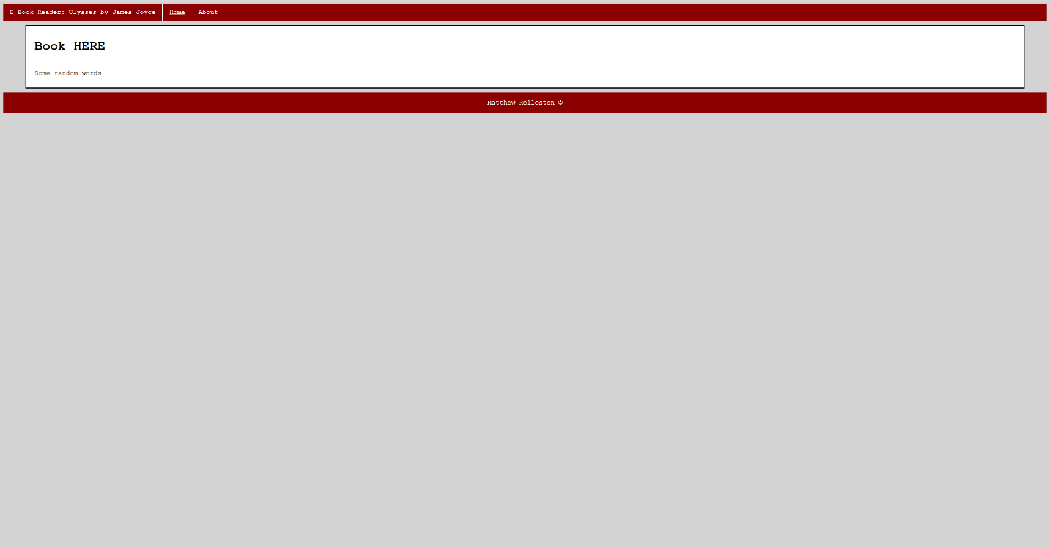**Home page**